PF Programming Practice Tasks
Loops and Arrays
Name: Shahzeb Roll No: 26K-3139

Task 01: ATM Transactions
Code:
#include <stdio.h>

int main()
{
float balance = 50000, amount;
int count = 0;

printf("Enter withdrawal amount: ");
scanf("%f", &amount);

while (amount > 0)
{
if (amount <= balance)
{
balance = balance - amount;
count++;
}
else
{
printf("Insufficient balance!\n");
}

printf("Enter withdrawal amount: ");
scanf("%f", &amount);
}

printf("\nRemaining balance = %.2f\n", balance);
printf("Number of withdrawals = %d\n", count);

return 0;
}
Output:
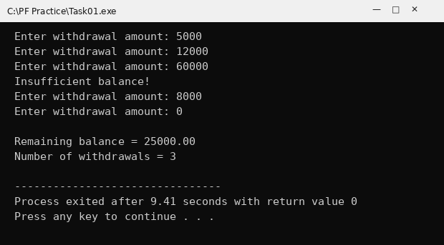

Task 02: Student Marks
Code:
#include <stdio.h>

int main()
{
int marks, total = 0, students = 0;
float average;

printf("Enter marks (-1 to stop): ");
scanf("%d", &marks);

while (marks != -1)
{
if (marks >= 0 && marks <= 100)
{
total = total + marks;
students++;
}
else
{
printf("Invalid marks! Enter between 0 and 100.\n");
}

printf("Enter marks (-1 to stop): ");
scanf("%d", &marks);
}

if (students > 0)
average = (float)total / students;
else
average = 0;

printf("\nTotal marks = %d\n", total);
printf("Number of students = %d\n", students);
printf("Average marks = %.2f\n", average);

return 0;
}
Output:
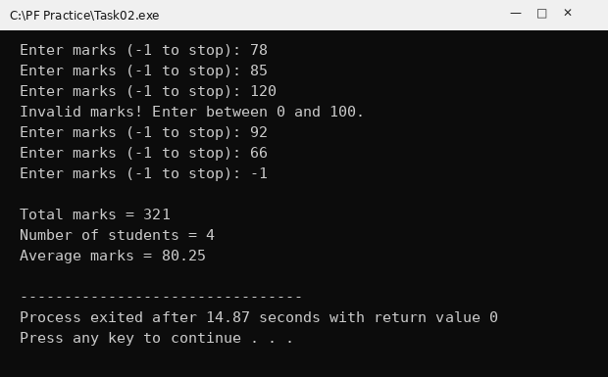

Task 03: Mobile Recharge
Code:
#include <stdio.h>

int main()
{
float amount, total = 0;
int attempts = 0;

printf("Enter recharge amount: ");
scanf("%f", &amount);

while (amount > 0)
{
total = total + amount;
attempts++;

if (total > 5000)
{
printf("Recharge Limit Reached\n");
break;
}

printf("Enter recharge amount: ");
scanf("%f", &amount);
}

printf("\nTotal recharged amount = %.2f\n", total);
printf("Number of recharge attempts = %d\n", attempts);

return 0;
}
Output:
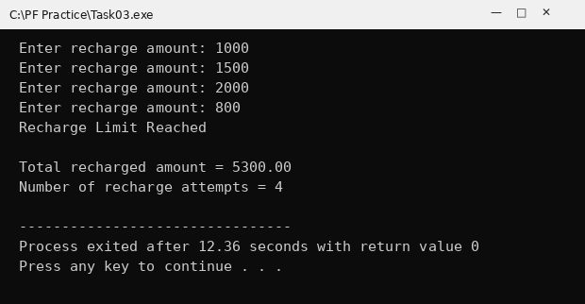

Task 04: Online Shopping
Code:
#include <stdio.h>

int main()
{
float price, total = 0, discount = 0, finalAmount;
int choice;

do
{
printf("Enter price of item: ");
scanf("%f", &price);
total = total + price;

printf("Add another item? (1 = Yes, 0 = No): ");
scanf("%d", &choice);
}
while (choice == 1);

if (total > 10000)
discount = total * 10 / 100;

finalAmount = total - discount;

printf("\nTotal price = %.2f\n", total);
printf("Discount = %.2f\n", discount);
printf("Final amount = %.2f\n", finalAmount);

return 0;
}
Output:
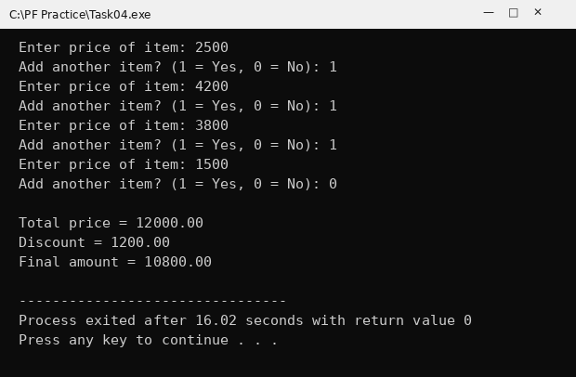

Task 05: Restaurant Bill
Code:
#include <stdio.h>

int main()
{
float price, bill = 0, discount = 0, finalBill;
int another;

do
{
printf("Enter price of item: ");
scanf("%f", &price);
bill = bill + price;

printf("Order another item? (1 = Yes, 0 = No): ");
scanf("%d", &another);
}
while (another == 1);

if (bill > 5000)
discount = bill * 5 / 100;

finalBill = bill - discount;

printf("\nTotal bill = %.2f\n", bill);
printf("Discount = %.2f\n", discount);
printf("Final bill = %.2f\n", finalBill);

return 0;
}
Output:
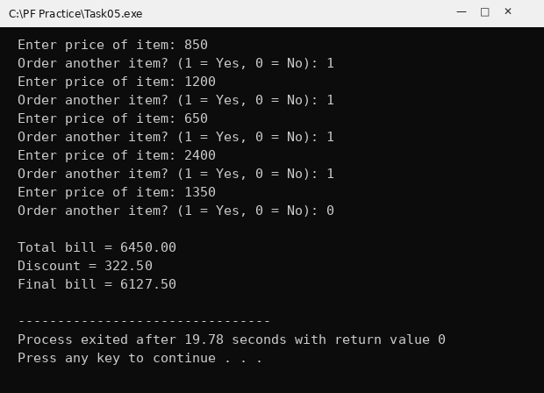

Task 06: Login Attempts
Code:
#include <stdio.h>

int main()
{
int pin, attempts = 0;

while (attempts < 3)
{
printf("Enter PIN: ");
scanf("%d", &pin);

if (pin == 1234)
{
printf("Login Successful\n");
break;
}
else
{
attempts++;
printf("Wrong PIN! Remaining attempts: %d\n", 3 - attempts);
}
}

if (attempts == 3)
printf("Account Locked\n");

return 0;
}
Output (Run 1):
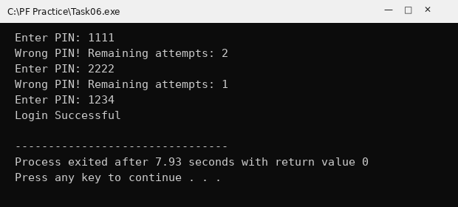
Output (Run 2):
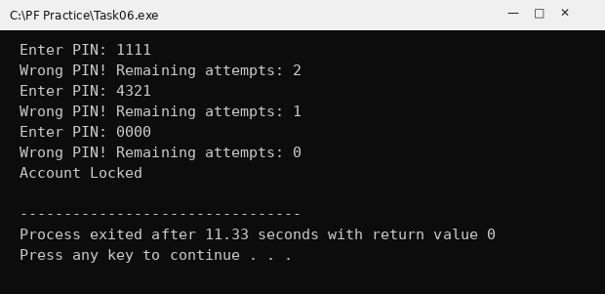

Task 07: Student Marks Analysis
Code:
#include <stdio.h>

int main()
{
int marks[5], i;
int total = 0, highest, lowest;
float average;

for (i = 0; i < 5; i++)
{
printf("Enter marks of student %d: ", i + 1);
scanf("%d", &marks[i]);
}

highest = marks[0];
lowest = marks[0];

for (i = 0; i < 5; i++)
{
total = total + marks[i];

if (marks[i] > highest)
highest = marks[i];

if (marks[i] < lowest)
lowest = marks[i];
}

average = total / 5.0;

printf("\nTotal marks = %d\n", total);
printf("Average marks = %.2f\n", average);
printf("Highest marks = %d\n", highest);
printf("Lowest marks = %d\n", lowest);

return 0;
}
Output:
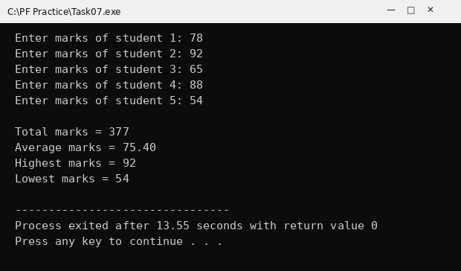

Task 08: Shopping Cart
Code:
#include <stdio.h>

int main()
{
float prices[5], total = 0, discount = 0, finalAmount;
int i;

for (i = 0; i < 5; i++)
{
printf("Enter price of product %d: ", i + 1);
scanf("%f", &prices[i]);
}

for (i = 0; i < 5; i++)
{
total = total + prices[i];
}

if (total > 10000)
discount = total * 0.10;

finalAmount = total - discount;

printf("\nOriginal total = %.2f\n", total);
printf("Discount = %.2f\n", discount);
printf("Final amount = %.2f\n", finalAmount);

return 0;
}
Output:
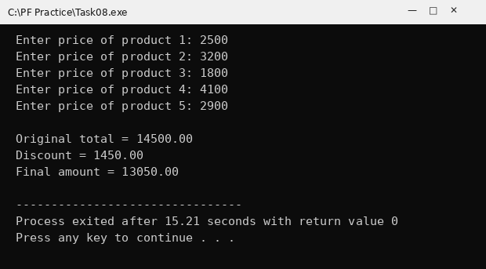

Task 09: Electricity Bill Analysis
Code:
#include <stdio.h>

int main()
{
int units[5], i;
int totalUnits = 0, highest, lowest;
float bill, totalAmount = 0;

for (i = 0; i < 5; i++)
{
printf("Enter units of household %d: ", i + 1);
scanf("%d", &units[i]);
}

highest = units[0];
lowest = units[0];

for (i = 0; i < 5; i++)
{
totalUnits = totalUnits + units[i];

if (units[i] > highest)
highest = units[i];

if (units[i] < lowest)
lowest = units[i];

bill = units[i] * 10;

if (units[i] > 500)
bill = bill + bill * 0.05;

totalAmount = totalAmount + bill;
}

printf("\nTotal units consumed = %d\n", totalUnits);
printf("Highest units = %d\n", highest);
printf("Lowest units = %d\n", lowest);
printf("Total amount collected = %.2f rupees\n", totalAmount);

return 0;
}
Output:
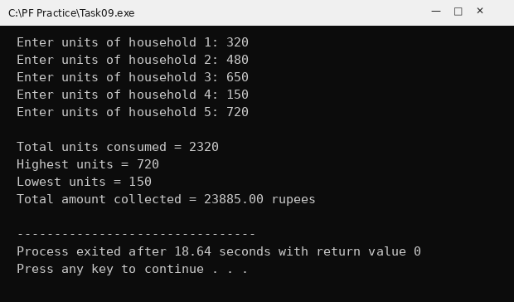

Task 10: Shoe Shop Price Analysis
Code:
#include <stdio.h>

int main()
{
float price[5], highest, lowest, total = 0, average;
int i;

for (i = 0; i < 5; i++)
{
printf("Enter price of shoes %d: ", i + 1);
scanf("%f", &price[i]);
}

highest = price[0];
lowest = price[0];

for (i = 0; i < 5; i++)
{
total = total + price[i];

if (price[i] > highest)
highest = price[i];

if (price[i] < lowest)
lowest = price[i];
}

average = total / 5;

printf("\nHighest price = %.2f\n", highest);
printf("Lowest price = %.2f\n", lowest);
printf("Total price = %.2f\n", total);
printf("Average price = %.2f\n", average);

return 0;
}
Output:
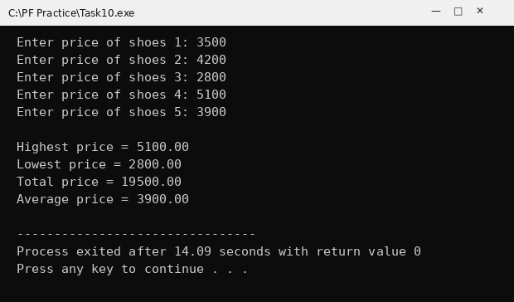

Task 11: Electricity Bill System
Code:
#include <stdio.h>

int main()
{
int units[5], i;
float bill[5], total = 0;

for (i = 0; i < 5; i++)
{
printf("Enter units of household %d: ", i + 1);
scanf("%d", &units[i]);
}

for (i = 0; i < 5; i++)
{
bill[i] = units[i] * 10;

if (units[i] > 500)
bill[i] = bill[i] + bill[i] * 5 / 100;

total = total + bill[i];
}

printf("\n");
for (i = 0; i < 5; i++)
{
printf("Bill of household %d = %.2f rupees\n", i + 1, bill[i]);
}

printf("\nTotal amount collected = %.2f rupees\n", total);

return 0;
}
Output:
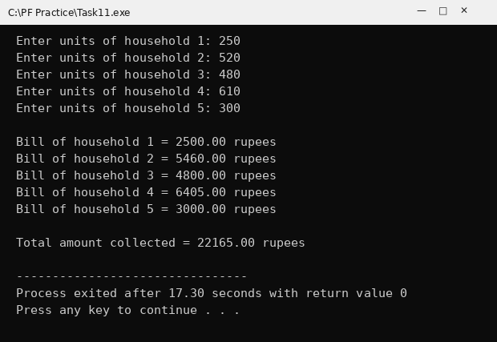

Task 12: Shoe Price Average
Code:
#include <stdio.h>

int main()
{
float price[5], total = 0, average;
int i;

for (i = 0; i < 5; i++)
{
printf("Enter price of shoes %d: ", i + 1);
scanf("%f", &price[i]);
}

for (i = 0; i < 5; i++)
{
total = total + price[i];
}

average = total / 5;

printf("\nTotal price = %.2f\n", total);
printf("Average price = %.2f\n", average);

return 0;
}
Output:
